|  |  |
| --- | --- |
| Description: Vertical full colour positive | **Year 11 General Biology**  **Task 9 – Ecosystems Test** |

|  |  |  |  |
| --- | --- | --- | --- |
| **Name:** | **Teacher:** | **Date:** | **Score: /48** |

**Assessment type:** Test

**Conditions**

Time for the task: 55 minutes

**Task weighting** – 13%

Total 48 marks

**Structure of this paper**

|  |  |  |  |  |
| --- | --- | --- | --- | --- |
|  |  | Suggested working time (minutes) | Marks available | Mark achieved |
| Section 1 | Multiple choice | 15 minutes | **11** |  |
| Section 2 | Short answer | 20 minutes | **27** |  |
| Section 3 | Extended answer | 25 minutes | **12** |  |
|  |  | **Total** | **50** |  |

**Section 1: Multiple-choice (11 marks)**

This section has 11 questions. Answer all questions by circling the letter corresponding to the correct answer.

___________________________________________________________________

1. What is one way that Aboriginal and Torres Strait Islander people positively impact their local ecosystems?
2. Hunting down top predators in the food web.
3. Gathering plants for medicines.
4. Clearing land for housing.
5. Controlled fires to increase biodiversity.
6. Bacteria and fungi belong to an ecosystem group called:
7. Herbivores.
8. Decomposers.
9. Omnivores.
10. Carnivores.
11. As you move up the trophic levels:
12. The number of organisms stays the same but the size decreases.
13. The number of organisms increases.
14. The number of organisms decreases.
15. The number of organisms stays the same but the size increases.
16. Biodiversity is:
17. The variety of all the animals in an area.
18. The variety of all organisms in area.
19. The variety of all the plants in an area.
20. The variety of all bacteria and fungi in an area.
21. Herbivore, carnivore and omnivore are types of?
22. Producers
23. Consumers
24. Autotrophs
25. Symbiotes

Use the diagram below to answer the following questions

1. How many primary consumers are there in this food web?
2. 3
3. 5
4. 6
5. 4
6. How many organisms are both secondary and tertiary consumers in this food web?
7. 3
8. 2
9. 5
10. 4
11. If decomposers were removed from this food web:
12. Nutrients would not be returned to the soil in order for autotrophs to grow healthy
13. Waste and dead organisms would accumulate.
14. There would be a break in the flow of energy.
15. All of the above.
16. Which of the following comparisons concerning freshwater and marine fish is correct?

|  |  |  |
| --- | --- | --- |
|  | Biotic Factor | Abiotic Factor |
| a | Sand | Water |
| b | Plants | Water |
| c | Plants | Animals |
| d | Weather | Climate |

1. How much energy is passed up each trophic level?
2. 20%
3. 11%
4. 100%
5. 10%
6. A food chain is shows the:
7. What animal eats what
8. Flow of energy from one organism to another
9. Where animals live
10. How important biodiversity is

**End of Section 1**

**Section 2: Short answer (27 marks)**

*Write the answers for each question in the space provided.*

1. The diagram below illustrates a simple Australian food web. Use it to answer the questions below:

1. What is the original source of energy for this food web? (1 mark)

________________________________________________________________

1. The lizard can be at trophic level 1 or trophic level 2, explain how this is possible

(2 marks)

________________________________________________________________

________________________________________________________________

________________________________________________________________

1. Select and list three food chains from the food web above (3 marks)

________________________________________________________________

________________________________________________________________

________________________________________________________________

1. Describe what would happen to the food web if the lizard population was wiped out (3 marks)

____________________________________________________________________________________________________________________________________________________________________________________________________________________________________________________________________________________________________________

1. Using the diagram below explain how this change in intact natural land in Australia may have occurred. (3 marks)

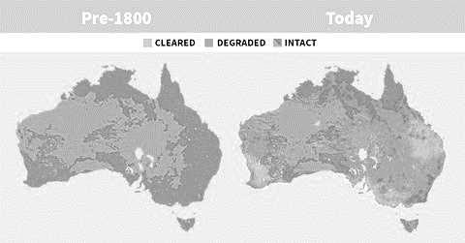

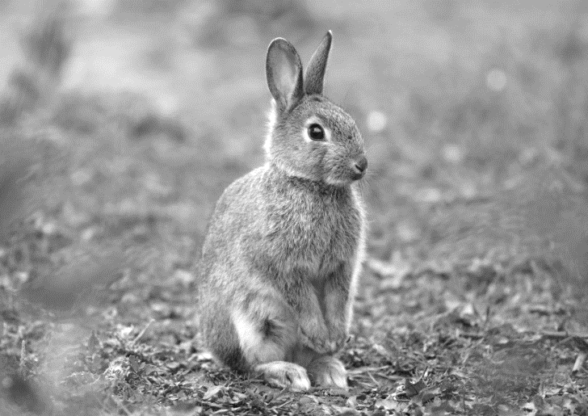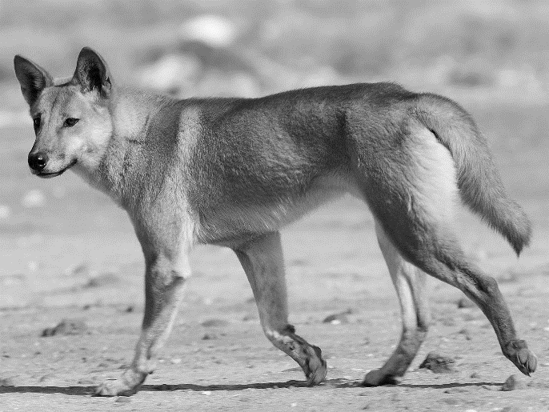

1. Dingoes were introduced to Australia approximately 3500 years ago, what effect do you think they had upon their introduction to Australia? Do you think their introduction to Australia was ecologically sustainable? Explain your answer (4 marks)

1. Compare and contrast the introduction of dingoes to Australia to the introduction of European rabbits to Australia? (3 marks)

________________________________________________________________

________________________________________________________________

1. List two things that animals from different species could compete for in an ecosystem. (2 marks)

________________________________________________________________________

________________________________________________________________________

1. Explain two forms of symbiotic relationship and provide an example of each.

(4 marks)

1. Contrast and compare one adaption that a predator may have to hunt prey verses one adaption that a prey animal may have to survive (2 marks)

**End of Section 2**

**Section 3: Extended answer (12 marks)**

*Write the answers for this question on the* ***lined paper*** *provided. Make sure you clearly number your answers.*

*In this section, answers may be presented in different ways provided that they communicate your ideas effectively.*

*You may choose to:*

* *write lists of points, with sentences which link them*
* *write concisely worded sentences*
* *use other appropriate ways to present ideas*

Humans can impact local ecosystems in several ways. List and describe three ways humans can negatively impact the ecosystems around them. Describe how animals could possibly adapt to these changes. Explain how humans could reduce the negative impacts you have listed or support the ecosystems that they change.

**__________________________________________________________________________________________________________________________________________________________________________________________________________________________________________________________________________________________________________________________________________________________________________________________________________________**

**_______________________________________________________________________________________________________________________________________________________________________________________________________________________________________________________________________________________________________________________________________________________________________________________________________________________________________________________________________________________________________________________________________________________________________________________________________________________________________________________________________________________________________________________________________________________________________________________________________________________________________________________________________________________________________________________________________________________________________________________________________________________________________________________________________________________________________________________________________________________________________________________________________________________________________________________________________________________________________________________________________________________________________________________________________________________________________________________________**

**____________________________________________________________________________________________________________________________________________________________________________________________________________________________________________________________________________**

**____________________________________________________________________________________________________________________________________________________________________________________________________________________________________________________________________________**

**End of Test**